ICS 1 – Computing Fundamentals

Laboratory Exercise #5
Posters

Name: Date:

Code/Schedule: Terminal #:

Topic(s) Covered: Creating Posters

Estimated Completion Time: 2 hours (2 meetings)

Objectives:

- To be able to create personalized posters.
- To be able to understand the importance of using.
- To be able to insert photos and graphics using word processors.

Discussions:

A poster is usually large sheet with writing or pictures on it that is displayed as a notice, advertisement, or for decoration.

Problem:
Create your own poster (Samples given below)
Insert only photos relevant to your topic/theme. Do not insert the whole poster copied from a website. Use formats and functions found in OpenOffice Writer only, and it should be done inside the laboratory room.
Posters should be personalized (should include your name or photo as the author)
Save the activity in your backpack and turn-in with Lab Activity 5-<last name> filename. Turn in via Edmodo on or before the due date.

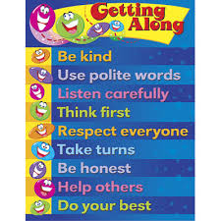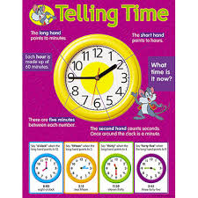

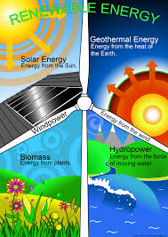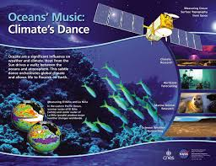

Laboratory Exercise Score Sheet

Criteria Score

- Proper images 20

- Correct choice of words 20

- Uses formatting creatively 20

- Organized contents 30

- Finished the exercise within the time-frame 10

